ANALYSE OF REDDIT 2012-01-02

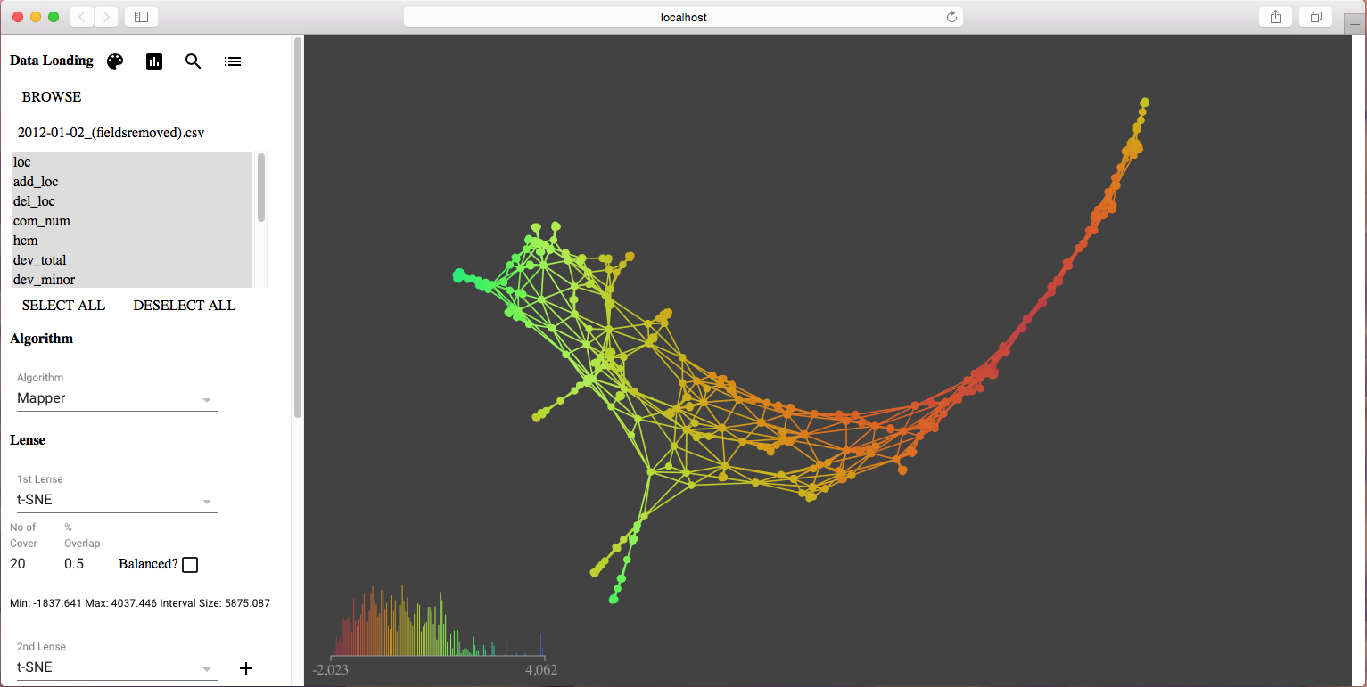

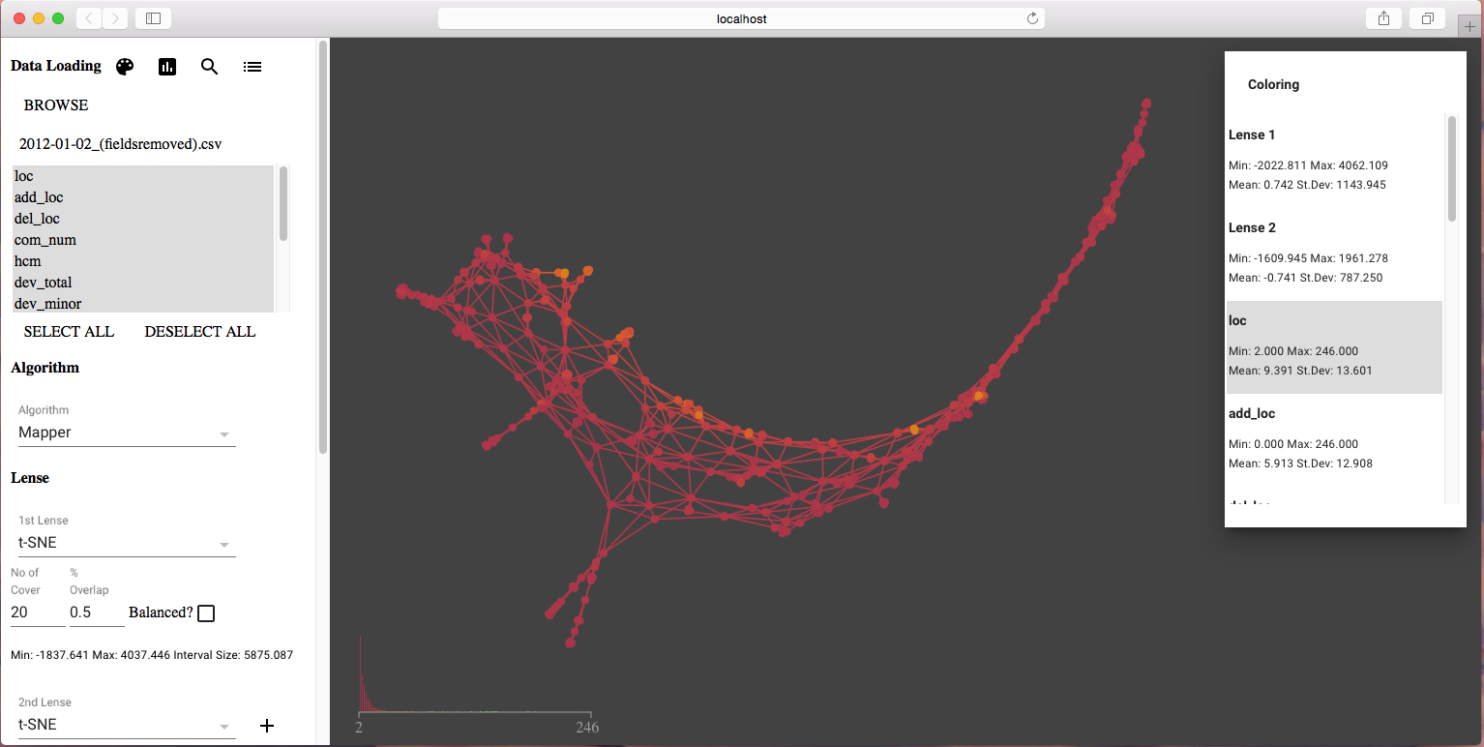

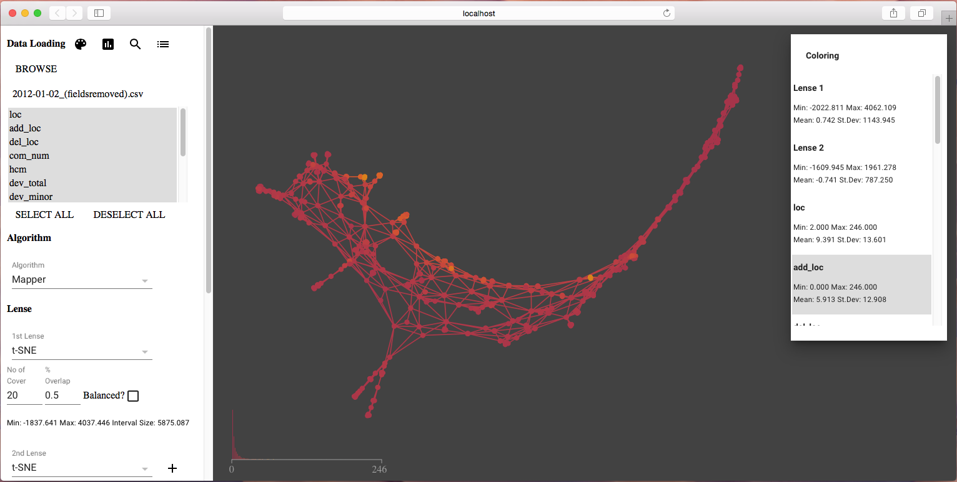

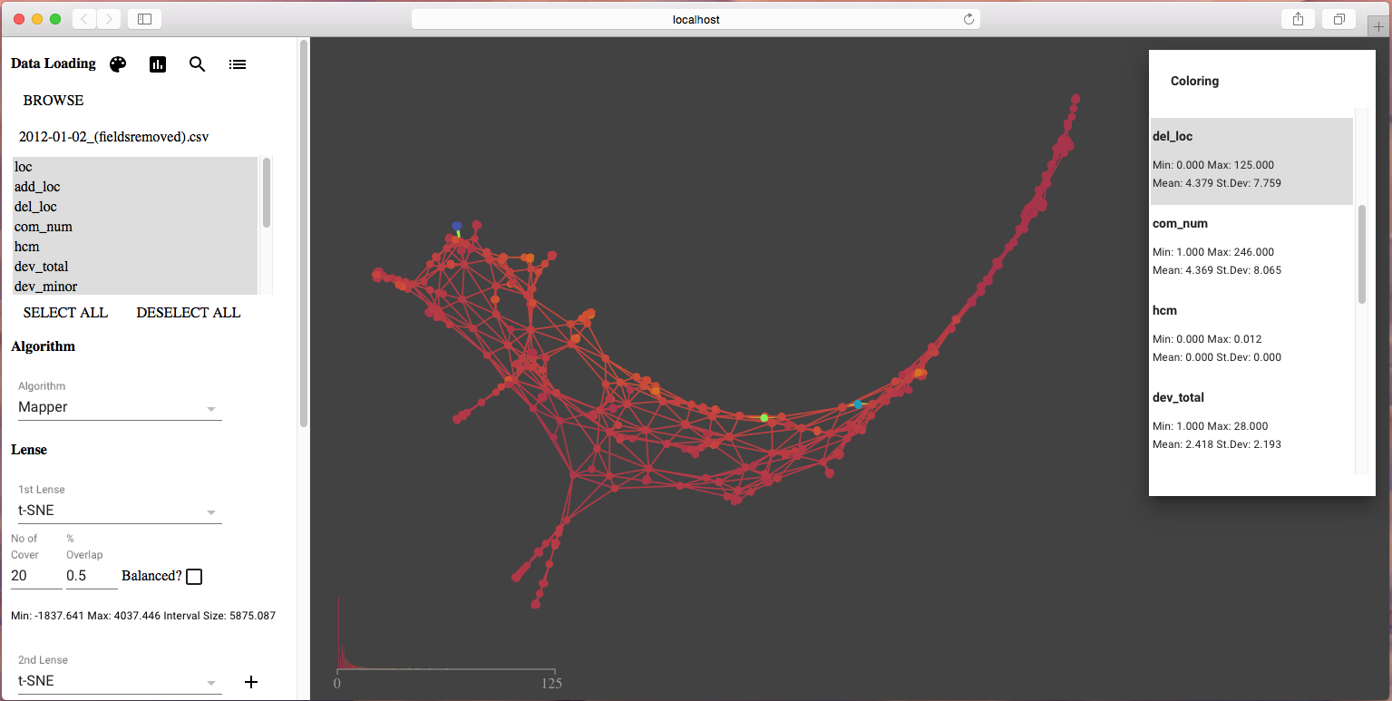

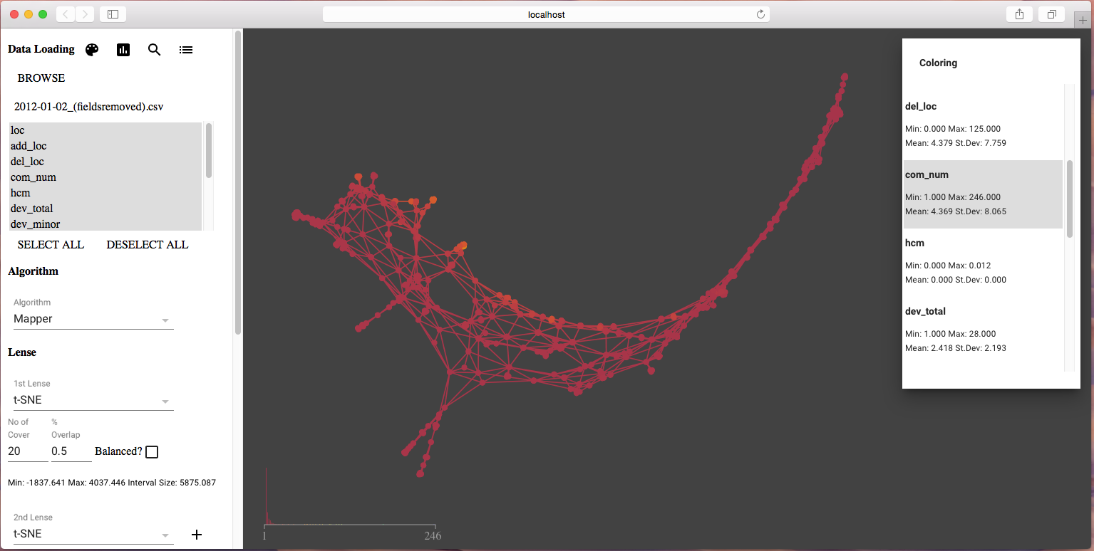

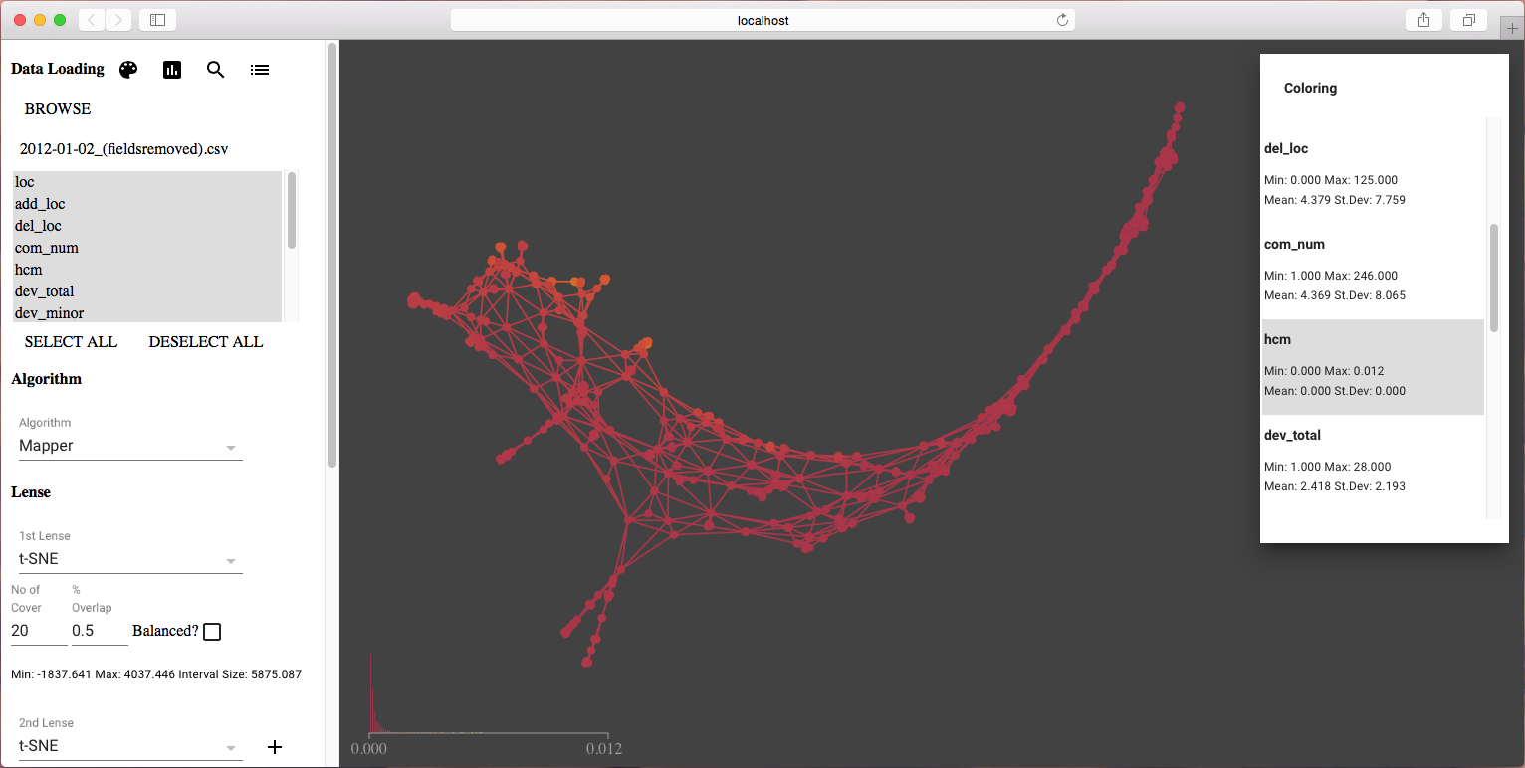

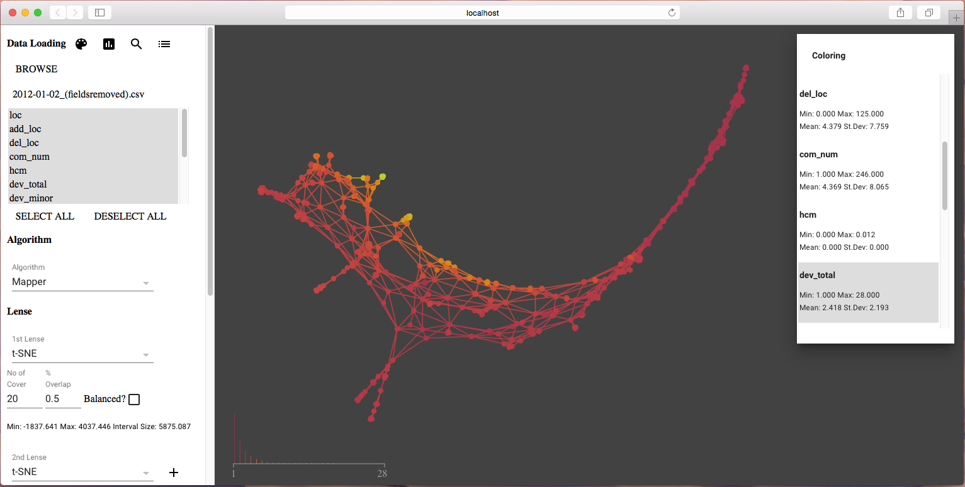

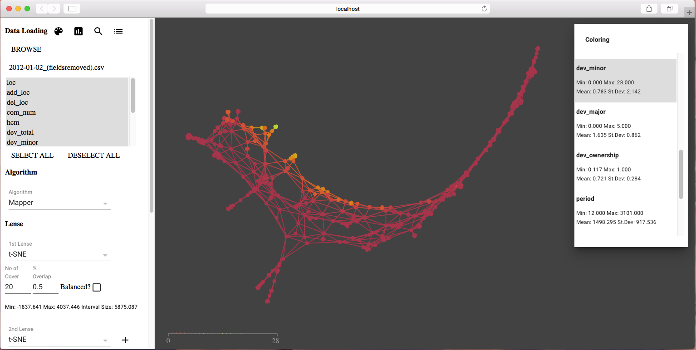

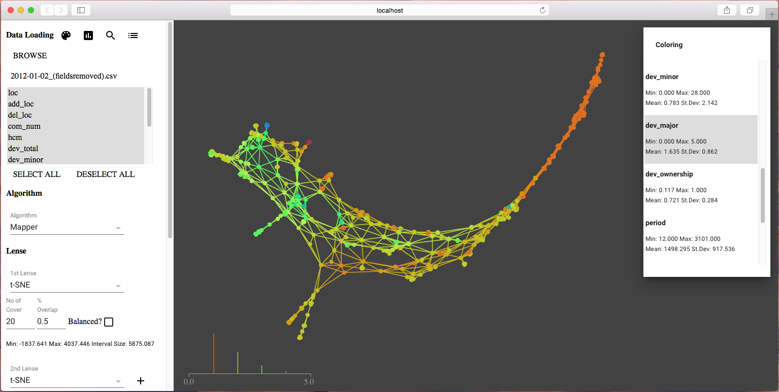

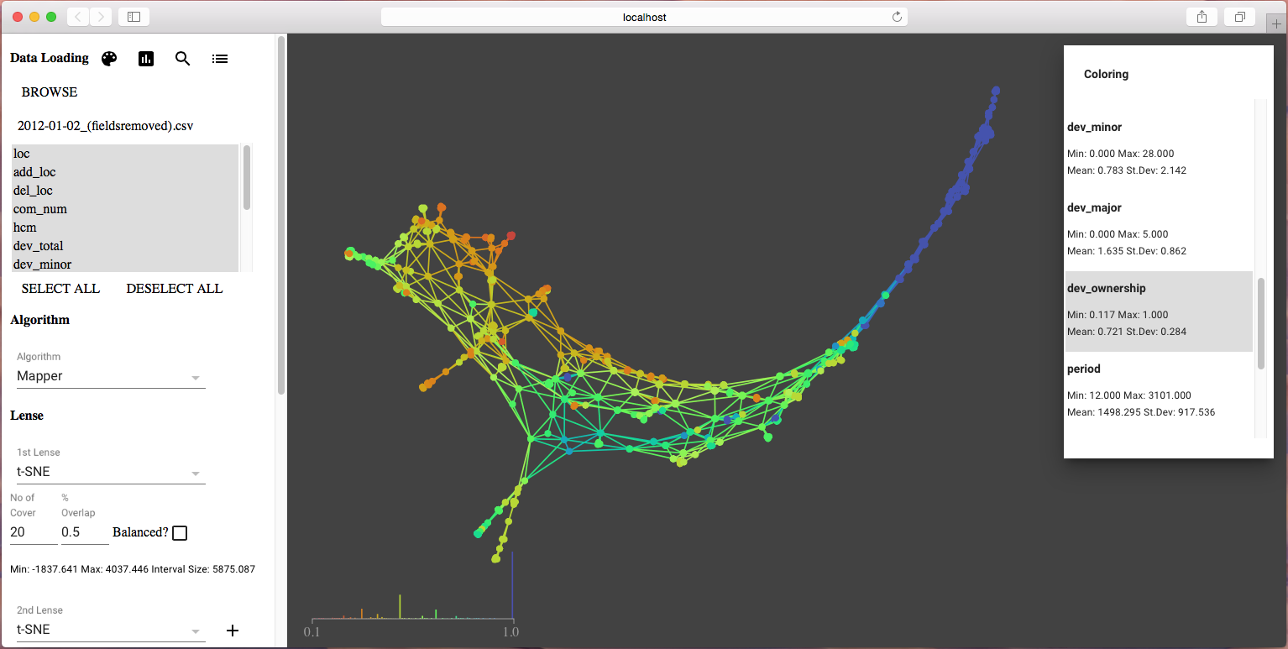

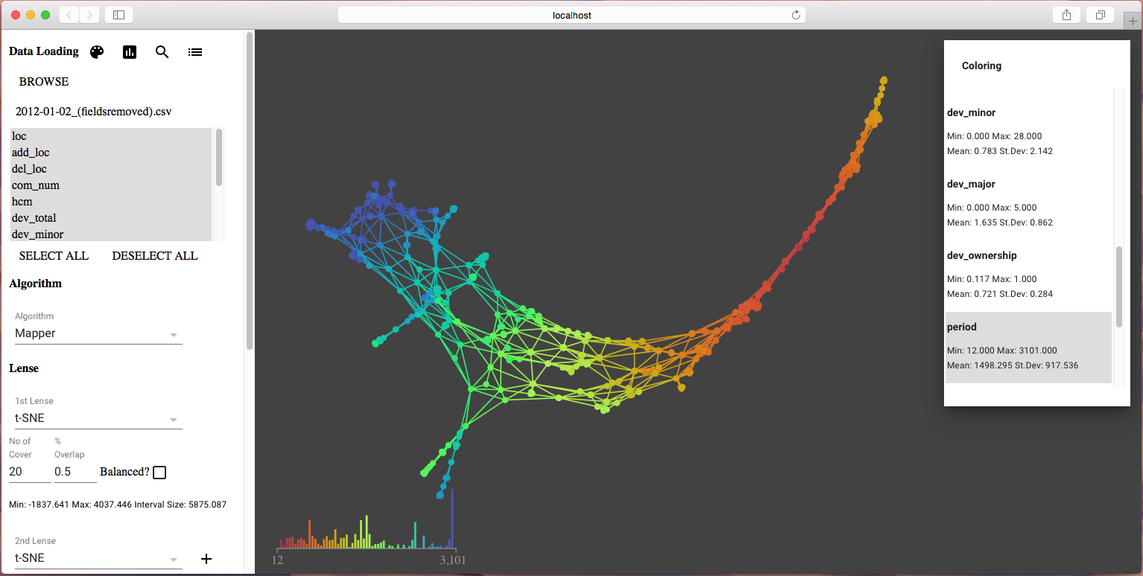

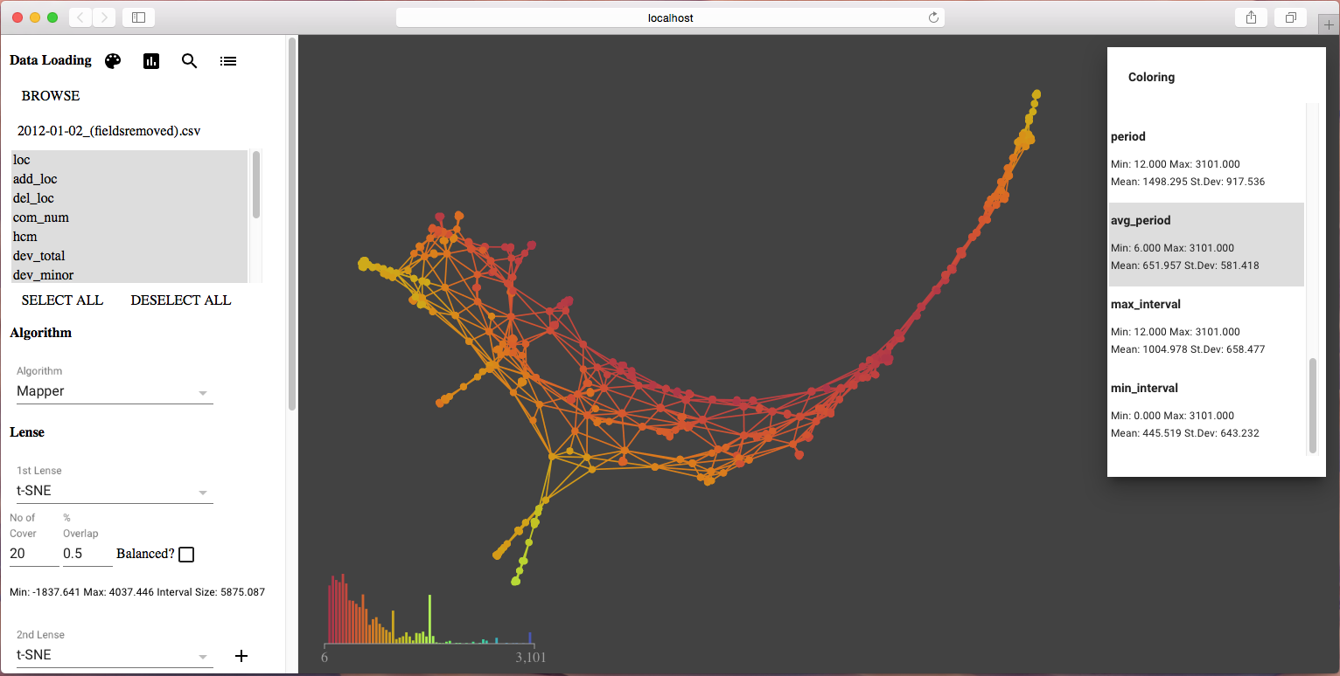

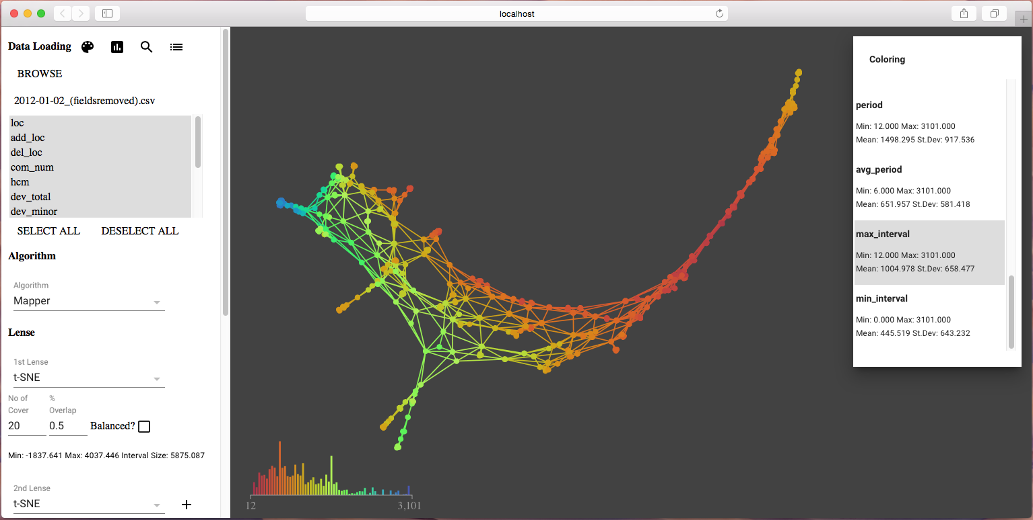

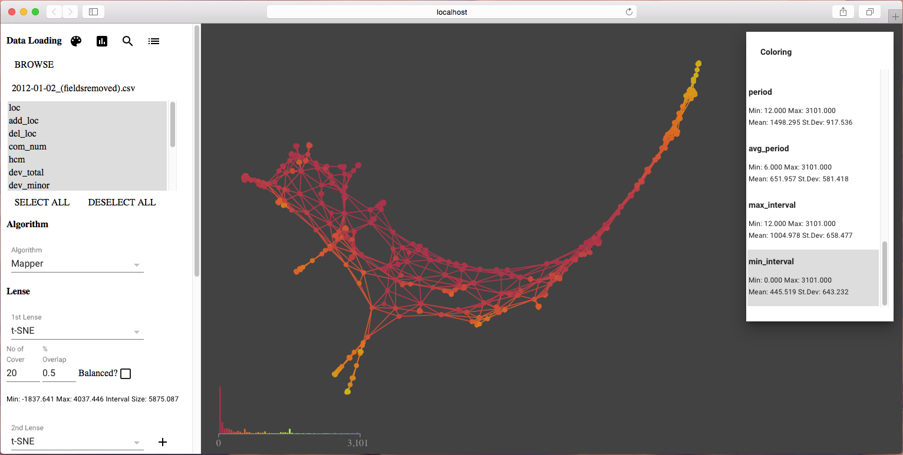

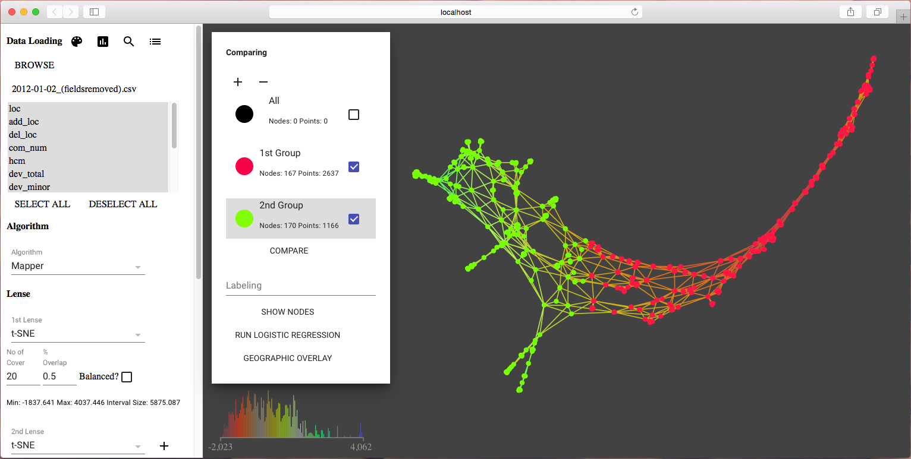

#### Analysis Result

|  |  |  |  |  |  |  |  |  |
| --- | --- | --- | --- | --- | --- | --- | --- | --- |
| **Variables** | **Group 1 min** | **Group 2 min** | **Group 1 mean** | **Group 2 mean** | **Group 1 median** | **Group 2 median** | **Group 1 max** | **Group 2 max** |
| loc | 2.0 | 2.0 | 9.016 | 12.527 | 6.0 | 6.0 | 106.0 | 246.0 |
| add_loc | 0.0 | 0.0 | 5.122 | 11.521 | 2.0 | 6.0 | 75.0 | 246.0 |
| del_loc | 0.0 | 0.0 | 4.131 | 7.66 | 2.0 | 5.0 | 106.0 | 125.0 |
| com_num | 1.0 | 2.0 | 3.279 | 9.165 | 2.0 | 6.0 | 74.0 | 246.0 |
| hcm | 0.0 | 0.0 | 0.0 | 0.001 | 0.0 | 0.001 | 0.002 | 0.012 |
| dev_total | 1.0 | 1.0 | 1.981 | 4.369 | 1.0 | 4.0 | 16.0 | 28.0 |
| dev_minor | 0.0 | 0.0 | 0.403 | 2.263 | 0.0 | 0.0 | 15.0 | 28.0 |
| dev_major | 0.0 | 0.0 | 1.578 | 2.105 | 1.0 | 2.0 | 5.0 | 5.0 |
| dev_ownership | 0.167 | 0.117 | 0.765 | 0.472 | 1.0 | 0.429 | 1.0 | 1.0 |
| period | 12.0 | 1455.0 | 907.172 | 2559.849 | 876.0 | 2570.0 | 2121.0 | 3101.0 |
| avg_period | 6.0 | 12.0 | 404.386 | 484.579 | 334.0 | 428.0 | 1067.0 | 1415.0 |
| max_interval | 12.0 | 166.0 | 641.508 | 1258.601 | 581.0 | 1210.0 | 1657.0 | 2877.0 |
| min_interval | 0.0 | 0.0 | 251.771 | 85.522 | 116.0 | 10.0 | 1067.0 | 1085.0 |